**DATA ENGINEERING INTERVIEW**

**INSTRUCTION**

**1) THREE** datasets are provide:

a) DVD rental which should be loaded to PostgreSQL database.

**DATA SET EXPLORATION**

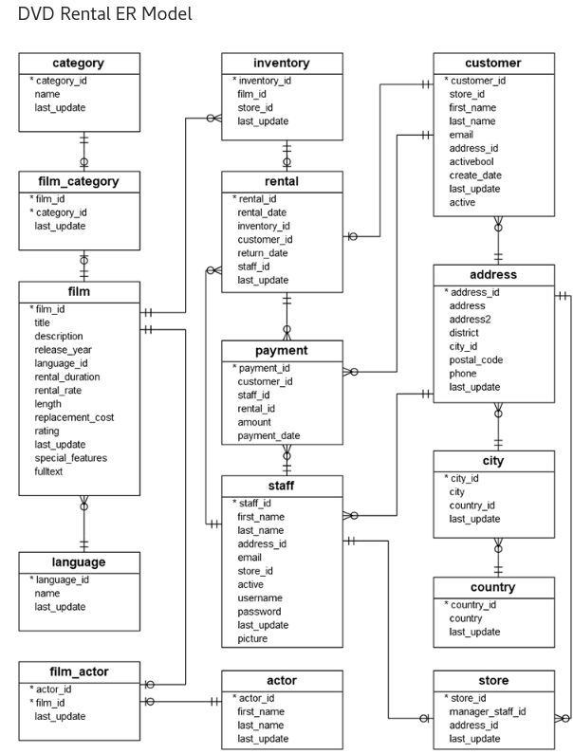

The DVD database represents the business processes of a DVD rental store. The DVD rental database has many objects including:

* 15 tables
* 1 trigger
* 7 views
* 8 functions
* 1 domain
* 13 sequences

There are 15 tables in the DVD Rental database:

* actor – stores actors data including first name and last name.
* film – stores film data such as title, release year, length, rating, etc.
* film_actor – stores the relationships between films and actors.
* category – stores film’s categories data.
* film_category- stores the relationships between films and categories.
* store – contains the store data including manager staff and address.
* inventory – stores inventory data.
* rental – stores rental data.
* payment – stores customer’s payments.
* staff – stores staff data.
* customer – stores customer data.
* address – stores address data for staff and customers
* city – stores city names.
* country – stores country names.

b) Big-mart sales which is a csv file.

C) Resource Monitoring Data-set(csv files)

DETAILED DESCRIPTIONS OF DATA FILES

==============================================

**Brief descriptions of the data.**

physical_cores -> Physical Core: is an independent CPU instance on a multi core-processor.

logical_cores -> Logical Core: intern refers to the ability of each core doing 2 or more tasks simultaneously. This is achieved by enabling

hyper-threading on the cores. Each single physical core can be divided in to multiple logical core by enabling

hyper-threading on them.

max_cpu_frequency -> Maximum cpu Clock speeds measured in megahertz

min_cpu_frequency -> Minimum cpu Clock speeds measured in megahertz

current_cpu_frequency -> Current cpu Clock speeds measured in megahertz

total_ram -> Total ram measured in GB, MB, KB or B depending on ram available in test machine

total_available_ram -> Total available ram measured in GB, MB, KB or B depending on ram available in test machine

total_swap -> Total swap space measured in GB, MB, KB or B depending on ram available in test machine

free_swap -> Total free swap measured in GB, MB, KB or B depending on ram available in test machine

start_time -> Time in seconds seconds since the epoch (Assumed to be January 1, 1970, 00:00:00 (UTC)) at the start of the task type

stop_time -> Time in seconds seconds since the epoch (Assumed to be January 1, 1970, 00:00:00 (UTC)) at the end of the task type

time_spend -> Time spend on the task it the difference between stop_time and start_time in second

task_count -> Total Individual task of type X performed in a give time

task_type -> Type of task that they system is working on

2) Submission can be in the following format:

a) Json file.

b) Notebook.

c) python file.

**SECTION ONE**

1.a)Using data-set provided (DVD rental) write python code to output the following object and save it to a json file.

*{*

*"customer_name":"customer_name",*

*"address":"address",*

*"email":"email",*

*payment:[*

*"customer_id":"customer_id"*

*"staff_id":"staff_id",*

*"rental_id":"rental_id"*

*],*

*film_section:[*

*"title":"title",*

*"description":"description",*

*"rental_duration":"rental_duration"*

*],*

*store_section:[*

*"store_id":"staff_id",*

*"manager_staff_id":"manager_staff_id"*

*]*

*}*

1.b) Mock an endpoint for the above object.

2.Using pandas analyze how many customer are from Egypt, Kuwait, India and return their Name as First Name and Second Name.

3.Create a list of Customers with their payments.

**SECTION TWO**

1.Using the big-mart data-set provided and Pandas perform Exploratory Data analysis considering the below:

a) Uni-variant analysis.

b) Multi-variant analysis.

c) Bi-variant analysis.

**SECTION THREE**

1.Using python code write a function that will convert the below dictionary to a csv file.

{  
 "successful": [  
 "30000922",  
 "30000910"  
   
 ],  
 "id_undetermined": [  
 "30000911",  
 "30000913"  
 ],  
 "unsuccessful": [  
 {  
 "id_number": "30000921",  
 "errors": {  
 "fee_status": [  
 "\"KNOWN\" is not a valid choice."  
 ]  
 }  
 },  
 {  
 "id_number": "29000921",  
 "errors": {  
 "fee_status": [  
 "\"KNOWN\" is not a valid choice."  
 ],  
 "fee_receipt": {  
 "0": {  
 "registration_section": {  
 "9": {  
 "sectionNo": [  
 "This field may not be null."  
 ]  
 }  
 }  
 }  
 }  
 }  
 }

**SECTION FOUR**

Using Resource Monitoring Data provided create recommender engine considering the below:

a) Resource, Task Type and Task Count can predict the time that will be spend with some key resource requirements?**Hint:**Use data-set named *“test_resource_data_q1”*

b) Task Type, Task Count and Time Spend can predict the resources required to perform the task as specified. **Hint:**Use data-set named *“test_resource_data_q2”*

**Note:**

It will be an added advantage if the model can be provided with an interface for Easy Use.

**Submission:**

1) Well commented python Model Creation code

2) Prediction for Question 4 (a) and Question 4 (b) test data

3) Explanation of the model and results finding